Title of Manuscript
A. A. Ali ^{*,1,a}, S. Abu^{2,b} and I. I. Ahmad^{1,c}
¹Department of Polymer Engineering, Faculty of Chemical Engineering Universiti Teknologi Malaysia, 81310 Skudai Johor, Malaysia
²Department of Thermofluid, Faculty of Mechanical Engineering Universiti Teknologi Malaysia, 81310 Skudai Johor, Malaysia
^{a,*}aqi@gmail.com, ^{b}abu@fkm.utm.my, ^{c}ida@cheme.utm.my

Abstract – Abstract must not exceed 300 words. Copyright © 2016 Penerbit Akademia Baru - All rights reserved.

Keywords: Microgels, Emulsion polymerization, Hydrogel, Copolymer
1.0 INTRODUCTION
Write your introduction here [1]. The last few decades have witnessed vast research on new types of heat transfer fluids, namely nanofluids. Nanofluid is a fluid that contains nanometer-sized solid particles. The nanofluid was introduced by Choi [2] and it has been proven to give better heat transfer efficiency compared to conventional fluids. Detailed reviews on the physical and thermal properties of nanofluids can be seen in review papers by several authors [3-5].
Second paragraph starts here. A nanofluid can be produced by dispersing metallic or non-metallic nanoparticles or nanofibers with a typical size of less than 100 nm in a base liquid. The presence of nanoparticles in base fluids contributes to better flow mixing and higher thermal conductivity compared to a pure fluid. A novel study by Matsuda [4] revealed that dispersion of A12O3 particles at 4.3 vol.% can increase the effective thermal conductivity of water by almost 30%.
2.0 NEW SECTION
2.1 Sub-Section
All of the materials were used without further purification.
2.1.1 Sub-sub section must be in italic
Nanoparticle was prepared by mixing the …
2.2 Synthesis of nanofluid
The formulation of rHDPE/EVA/ESP composites is shown in Table 1.
Table 1: Formulation of rHDPE/EVA/ESP composites
Composite code | rHDPE (phr) | EVA (phr) | ESP (phr) | ESP_{APTES} (phr)
rHDPE/EVA/ESP0 | 50 | 50 | - | -
rHDPE/EVA/ESP5 | 50 | 50 | 5 | -
For the purpose of measuring the performance of nanofluids with oxide nanoparticles, Lee and his co-workers [29] conducted a transient hot-wire experimental technique to determine the thermal conductivity of Al2O3 and CuO nanofluids. Good agreements were obtained when compared to Hamilton and Crosser’s thermal conductivity model.
3.0 RESULTS AND DISCUSSION
Dispersion of nanoparticles in a base fluid not only contributes to enhancement of thermal conductivity, but also because of greater heat transfer area, superior convective heat transfer coefficient can be achieved, which will also lead to enhancement of heat transfer. The structure of polymer emulsion microgels system containing a certain amount of water during film-forming process was revealed by SEM in Figure 1.
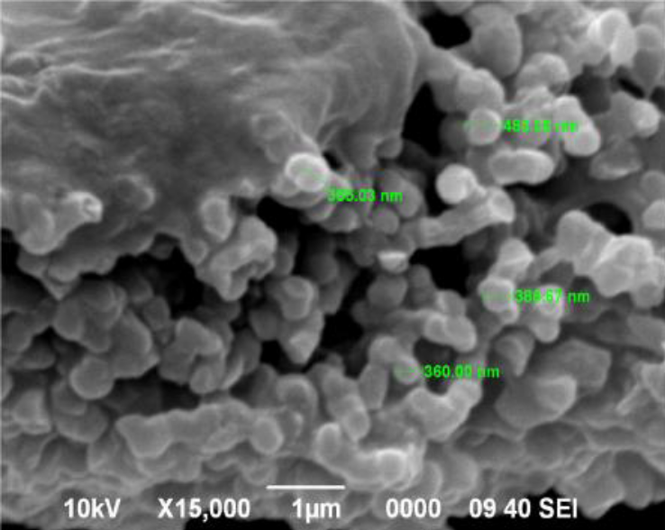
Figure 1: SEM images of spherical particles

4.0 CONCLUSION
This paper presents an inclusive review on the application of nanofluids for cooling of vehicle engine. The vast number of available references shows that nanofluids have a great application prospect in the development of modern engines. For engine cooling system, nanoparticles can be dispersed into the engine oil to enhance the thermal conductivity of the liquid. In addition, the presence of nanoparticles in engine oil will also improve the performance of lubricants and reduce friction. However, the optimum amount of nanoparticles in engine oil still remains unknown.
REFERENCES (Chicago Style)
[1] Chen, Shiyi, and Gary D. Doolen. "Lattice Boltzmann method for fluid flows." Annual review of fluid mechanics 30, no. 1 (1998): 329-364.
[2] Bejan, Adrian. Convection heat transfer. John wiley & sons, 2013.
[3] Tamura, I., Y. Tomota, and M. Ozawa. "Strength and ductility of Fe-Ni-C alloys composed of austenite and martensite with various strengths." In Proc. Conf. on Microstructure and Design of Alloys, Institute of Metals and Iron and Steel Institute, London. 1973, 1,(129), 611-615. 1973.

