TITLE IN CAPITAL LETTERS
TITLE IN CAPITAL LETTERS
TITLE IN CAPITAL LETTERS
TITLE IN CAPITAL LETTERS

WAN ZUKI AZMAN WAN MUHAMAD

UNIVERSITI TEKNOLOGI MALAYSIA
PSZ 19:16 (Pind. 1/13)
UNIVERSITI TEKNOLOGI MALAYSIA

DECLARATION OF THESIS / POSTGRADUATE PROJECT REPORT AND COPYRIGHT
Author’s full name :

Date of Birth :

Title :

Academic Session :

I declare that this thesis is classified as:

 | CONFIDENTIAL | (Contains confidential information under the Official Secret Act 1972)*
 | RESTRICTED | (Contains restricted information as specified by the organization where research was done)*
 | OPEN ACCESS | I agree that my thesis to be published as online open access (full text)

- I acknowledged that Universiti Teknologi Malaysia reserves the right as follows:
- The thesis is the property of Universiti Teknologi Malaysia
- The Library of Universiti Teknologi Malaysia has the right to make copies for the purpose of research only.
- The Library has the right to make copies of the thesis for academic exchange.
 |  |  | Certified by:
 | SIGNATURE OF STUDENT |  | SIGNATURE OF SUPERVISOR
 | PRS 153024 |  | AP. DR. KHAIRUR RIJAL JAMALUDIN
 | MATRIC NUMBER |  | NAME OF SUPERVISOR
 | Date: 20 JUNE 2015 |  | Date: 20 JUNE 2015

NOTES : If the thesis is CONFIDENTIAL or RESTRICTED, please attach with the letter from the organization with period and reasons for confidentiality or restriction

“Choose an item. hereby declare that Choose an item. have read this Choose an item. and in Choose an item.
opinion this Choose an item. is sufficient in term of scope and quality for the
award of the degree of Choose an item.”

Signature | : | ________________________________
Name of Supervisor | : | KHAIRUR RIJAL JAMALUDIN
Date | : | 9 May 2017

BAHAGIAN A - Pengesahan Kerjasama*

Adalah disahkan bahawa projek penyelidikan tesis ini telah dilaksanakan melalui
kerjasama antara ________________________dengan ________________________
Disahkan oleh:
Tandatangan : Tarikh :
Nama :
Jawatan :
(Cop rasmi)
* Jika penyediaan tesis atau projek melibatkan kerjasama.

BAHAGIAN B - Untuk Kegunaan Pejabat Sekolah Pengajian Siswazah

Tesis ini telah diperiksa dan diakui oleh:
Nama dan Alamat Pemeriksa Luar | :
Nama dan Alamat Pemeriksa Dalam | :
Nama Penyelia Lain (jika ada) | :

Disahkan oleh Timbalan Pendaftar di SPS:
Tandatangan | : |  | Tarikh : 15JULAI 2018
Nama | :

ON-LINE RECOGNITION OF DEVELOPING CONTROL CHART PATTERNS
TITLE
TITLE
TITLE

WAN ZUKI AZMAN WAN MUHAMAD

A Choose an item. submitted in Choose an item. of the
requirements for the award of the degree of
Choose an item.

Razak Faculty of Technology and Informatics
Universiti Teknologi Malaysia

JANUARY 2020

DECLARATION

I declare that this Choose an item. entitled “title of the thesis” is the result of my own research except as cited in the references. The Choose an item. has not been accepted for any degree and is not concurrently submitted in candidature of any other degree.
Signature | : | ....................................................
Name | :
Date | : | 10 November 2016

DEDICATION

This thesis is dedicated to my father, who taught me that the best kind of knowledge to have is that which is learned for its own sake. It is also dedicated to my mother, who taught me that even the largest task can be accomplished if it is done one step at a time.

ACKNOWLEDGEMENT
In preparing this thesis, I was in contact with many people, researchers, academicians, and practitioners. They have contributed towards my understanding and thoughts. In particular, I wish to express my sincere appreciation to my main thesis supervisor, Professor Dr. Mohd Shariff Nabi Baksh, for encouragement, guidance, critics and friendship. I am also very thankful to my co-supervisor Professor Dr Awaluddin Mohd Shaharoun and Associate Professor Dr. Hishamuddin Jamaluddin for their guidance, advices and motivation. Without their continued support and interest, this thesis would not have been the same as presented here.
I am also indebted to Universiti Teknologi Malaysia (UTM) for funding my Ph.D study. Librarians at UTM, Cardiff University of Wales and the National University of Singapore also deserve special thanks for their assistance in supplying the relevant literatures.
My fellow postgraduate student should also be recognised for their support. My sincere appreciation also extends to all my colleagues and others who have provided assistance at various occasions. Their views and tips are useful indeed. Unfortunately, it is not possible to list all of them in this limited space. I am grateful to all my family member.

ABSTRACT
The purpose of this study is to investigate the application of genetic algorithm (GA) in modelling linear and non-linear dynamic systems and develop an alternative model structure selection algorithm based on GA. Orthogonal least square (OLS), a gradient descent method was used as the benchmark for the proposed algorithm. A model structure selection based on modified genetic algorithm (MGA) has been proposed in this study to reduce problems of premature convergence in simple GA (SGA). The effect of different combinations of MGA operators on the performance of the developed model was studied and the effectiveness and shortcomings of MGA were highlighted. Results were compared between SGA, MGA and benchmark OLS method. It was discovered that with similar number of dynamic terms, in most cases, MGA performs better than SGA in terms of exploring potential solution and outperformed the OLS algorithm in terms of selected number of terms and predictive accuracy. In addition, the use of local search with MGA for fine-tuning the algorithm was also proposed and investigated, named as memetic algorithm (MA). Simulation results demonstrated that in most cases, MA is able to produce an adequate and parsimonious model that can satisfy the model validation tests with significant advantages over OLS, SGA and MGA methods. Furthermore, the case studies on identification of multivariable systems based on real experiment t al data from two systems namely a turbo alternator and a continuous stirred tank reactor showed that the proposed algorithm could be used as an alternative to adequately identify adequate and parsimonious models for those systems. Abstract must be bilingual. For a thesis written in Bahasa Melayu, the abstract must first be written in Bahasa Melayu and followed by the English translation. If the thesis is written in English, the abstract must be written in English and followed by the translation in Bahasa Melayu. The abstract should be brief, written in one paragraph and not exceed one (1) page. An abstract is different from synopsis or summary of a thesis. It should states the field of study, problem definition, methodology adopted, research process, results obtained and conclusion of the research. The abstract can be written using single or one and a half spacing. Example can be seen in Appendix 1 (Bahasa Melayu) and Appendix J (English).

ABSTRAK
Kajian ini dilakukan bertujuan mengkaji penggunaan algoritma genetik (GA)
dalam pemodelan sistem dinamik linear dan tak linear dan membangunkan kaedah alternatif bagi pcmilihan struktur model menggunakan GA. Algorithma kuasa dua terkecil ortogon (OLS), satu kaedah penurunan kecerunan digunakan sebagai bandingan bagi kaedah yang dicadangkan. Pcmilihan struktur model mengunakan kaedah algoritma genetik yang diubahsuai (MGA) dicadangkan dalam kajian ini bagi
mengurangkan masalah konvergens pramatang dalam algoritma genetik mudah (SGA). Kesan penggunaan gabungan operator MGA yang berbeza ke atas prestasi model yang terbentuk dikaji dan keberkesanan serta kekurangan MGA diu t arakan. Kajian simulasi dilakukan untuk membanding SGA, MGA dan OLS. Dengan meggunakan bilangan parametcr dinamik yang setara kajian ini mendapati, dalam kebanyakan kes, prestasi MGA adalah lebih baik daripada SGA dalam mencari penyelesaian yang berpotensi dan lebih berkebolehan daripada OLS dalam menentukan bilangan sebutan yang dipilih dan ketcpatan ramalan. Di samping itu, penggunaan carian tcmpatan dalam MGA untuk menambah baik algorithma tersebut dicadang dan dikaji, dinamai sebagai algoritma mcmetic (MA). Hasil simulasi menunjukkan, dalam kebanyakan kes, MA berkeupayaan menghasilkan model yang bersesuaian dan parsimoni dan mcmenuhi ujian pengsahihan model di samping mcmperolehi beberapa kelebihan dibandingkan dengan kaedah OLS, SGA dan MGA. Tambahan pula, kajian kes untuk sistcm berbilang pcmbolehubah menggunakan data eksperimental sebenar daripada dua sistem iaitu sistem pengulang-alik turbo dan reaktor teraduk berterusan menunjukkan algoritma ini boleh digunakan sebagai alternatif untuk mcmperolehi model termudah yang memadai bagi sistcm tersebut.

TABLE OF CONTENTS
 | TITLE | PAGE

DECLARATION iii
DEDICATION iii
ACKNOWLEDGEMENT iii
ABSTRACT iii
ABSTRAK iii
TABLE OF CONTENTS iii
LIST OF TABLES iii
LIST OF FIGURES iii
LIST OF ABBREVIATIONS iii
LIST OF SYMBOLS iii
LIST OF APPENDICES iii
CHAPTER 1 INTRODUCTION 3
1.1 Problem Background 3
1.2 Problem Background 3
1.3 Problem Statement 3
1.4 Research Goal 3
1.4.1 Research Objectives 3
1.5 Caption 3
1.6 Quotation 3
1.7 Equation 3
CHAPTER 2 LITERATURE REVIEW 3
2.1 Introduction 3
2.1.1 State-of-the-Arts 3
2.2 Limitation 3
2.3 Research Gap 3
CHAPTER 3 RESEARCH METHODOLOGY 3
3.1 Introduction 3
3.1.1 Proposed Method 3
3.1.1.1 Research Activities 3
3.2 Tools and Platforms 3
3.3 Chapter Summary 3
CHAPTER 4 PROPOSED WORK 3
4.1 The Big Picture 3
4.2 Analytical Proofs 3
4.3 Result and Discussion 3
4.4 Chapter Summary 3
CHAPTER 5 CONCLUSION AND RECOMMENDATIONS 3
5.1 Research Outcomes 3
5.2 Contributions to Knowledge 3
5.3 Future Works 3
REFERENCES 3
LIST OF PUBLICATIONS 3

LIST OF TABLES
TABLE NO. | TITLE | PAGE
Table ‎1.1 The role of statistical quality engineering tools and methodologies 3
Table ‎1.2 Basic ANN models used for control chart pattern recognition 3
Table ‎2.1 Regression analysis for the results of preliminary feature screening 3
Table ‎2.2 Estimated effects and regression coefficients for the recogniser's performance (reduced model) 3
Table ‎5.1 Example Repeated Header Table 3

LIST OF FIGURES
FIGURE NO. | TITLE | PAGE
Figure ‎1.1 Trends leading to the problem using MZJ Formatting Method 3
Figure ‎1.2 Design and development phases of the proposed scheme (Muhamad, 2018) 3
Figure ‎2.1 Continuous variability reduction using SPC chart (Revelle and Harrington, 1992) 3
Figure ‎2.2 Typical fully developed patterns on Shewhart control chart (Cheng, 1989) 3
Figure ‎3.1 Example of Formatting Method 3
Figure ‎4.1 This is MZJ original idea 3
Figure ‎4.2 The method for hig performance formatting 3

LIST OF ABBREVIATIONS
ANN | - | Artificial Neural Network
GA | - | Genetic Algorithm
PSO | - | Particle Swarm Optimization
MTS | - | Mahalanobis Taguchi System
MD | - | Mahalanobis Distance
TM | - | Taguchi Method
UTM | - | Universiti Teknologi Malaysia
XML | - | Extensible Markup Language
ANN | - | Artificial Neural Network
GA | - | Genetic Algorithm
PSO | - | Particle Swarm Optimization

LIST OF SYMBOLS
δ | - | Minimal error
 | - | Diameter
 | - | Force
 | - | Velocity
 | - | Pressure
 | - | Moment of Inersia
 | - | Radius
 | - | Reynold Number

LIST OF APPENDICES
APPENDIX | TITLE | PAGE
Appendix A Mathematical Proofs 3
Appendix B Psuedo Code 3
Appendix C Time-series Results Long Long Long Long Long Long Long Long Long Long 3

INTRODUCTION

Problem Background
Video provides a powerful way to help you prove your point. When you click Online Video, you can paste in the embed code for the video you want to add. You can also type a keyword to search online for the video that best fits your document. To make your document look professionally produced, Word provides header, footer, cover page, and text box designs that complement each other. For example, you can add a matching cover page, header, and sidebar. “For the first paragraph, use ‘Para 2 lines’ style”
Video provides a powerful way to help you prove your point. When you click Online Video, you can paste in the embed code for the video you want to add. You can also type a keyword to search online for the video that best fits your document. To make your document look professionally produced, Word provides header, footer, cover page, and text box designs that complement each other. For example, you can add a matching cover page, header, and sidebar. Click Insert and then choose the elements you want from the different galleries. Themes and styles also help keep your document coordinated. When you click Design and choose a new Theme, the pictures, charts, and SmartArt graphics change to match your new theme. “For the last paragraph/single paragraph in the section, use ‘Para 4 lines’ style”

Problem Background
Video provides a powerful way to help you prove your point. When you click Online Video, you can paste in the embed code for the video you want to add. You can also type a keyword to search online for the video that best fits your document. To make your document look professionally produced, Word provides header, footer, cover page, and text box designs that complement each other. For example, you can add a matching cover page, header, and sidebar. Click Insert and then choose the elements you want from the different galleries.
Themes and styles also help keep your document coordinated. When you click Design and choose a new Theme, the pictures, charts, and SmartArt graphics change to match your new theme. When you apply styles, your headings change to match the new theme. Save time in Word with new buttons that show up where you need them. To change the way a picture fits in your document, click it and a button for layout options appears next to it. When you work on a table, click where you want to add a row or a column, and then click the plus sign.

Problem Statement

Research Goal

Research Objectives
The objectives of the research are :
- To estimate the parameters
- Item 1
- Item 2
- To define the best parameter estimate.

Captions
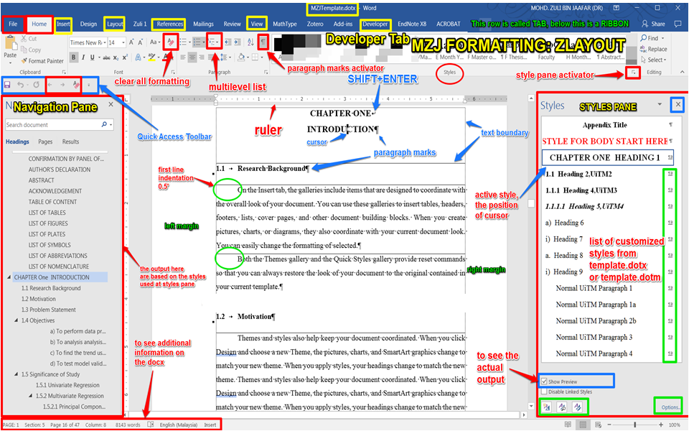
Figure 1.1 Trends leading to the problem using MZJ Formatting Method
(If the caption is written in a single line, use Caption for Figure UTM)

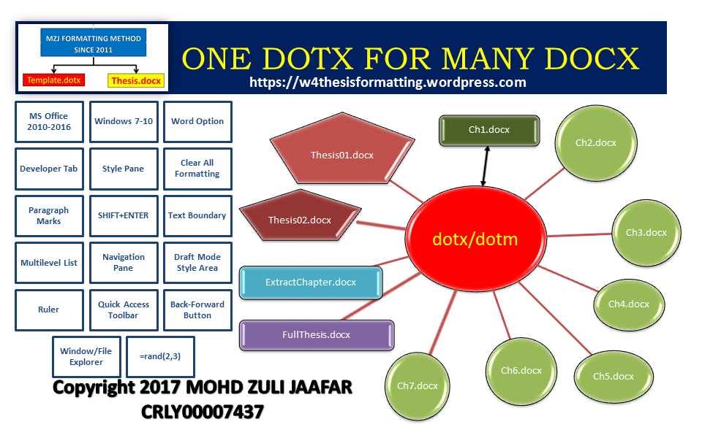
Figure 1.2 Design and development phases of the proposed scheme (Muhamad, 2018)
(If the caption is written more than one line, use Caption for Figure UTM 2 line)

Table 1.1 The role of statistical quality engineering tools and methodologies
(If the caption is written in a single line, use Caption for Table UTM)

Table 1.2 Basic ANN models used for control chart pattern recognition
(If the caption is written more than one line, use Caption for Table UTM 2 line)

Quotation
After deliberating on doctoral education in Australia in the 1990s, one observer I Australia writes:
The lack of any significant formal course work within our Ph.D. and master degrees by research has continued for three decades. The focus of our Ph.D. research type degrees continues to be the research project, and this is almost the only medium by which education is accomplished.
(Stranks, 1984:171)

Equation
(1.1)
Video provides a powerful way to help you prove your point. When you click Online Video, you can paste in the embed code for the video you want to add. You can also type a keyword to search online for the video that best fits your document. To make your document look professionally produced, Word provides header, footer, cover page, and text box designs that complement each other. For example, you can add a matching cover page, header, and sidebar. Click Insert and then choose the elements you want from the different galleries. Themes and styles also help keep your document coordinated. When you click Design and choose a new Theme, the pictures, charts, and SmartArt graphics change to match your new theme. When you apply styles, your headings change to match the new theme. Save time in Word with new buttons that show up where you need them.
To change the way a picture fits in your document, click it and a button for layout options appears next to it. When you work on a table, click where you want to add a row or a column, and then click the plus sign. Reading is easier, too, in the new Reading view. You can collapse parts of the document and focus on the text you want. If you need to stop reading before you reach the end, Word remembers where you left off - even on another device. Video provides a powerful way to help you prove your point. When you click Online Video, you can paste in the embed code for the video you want to add. You can also type a keyword to search online for the video that best fits your document. To make your document look professionally produced, Word provides header, footer, cover page, and text box designs that complement each other. For example, you can add a matching cover page, header, and sidebar.

LITERATURE REVIEW

Introduction
Video provides a powerful way to help you prove your point. When you click Online Video, you can paste in the embed code for the video you want to add. You can also type a keyword to search online for the video that best fits your document. To make your document look professionally produced, Word provides header, footer, cover page, and text box designs that complement each other. For example, you can add a matching cover page, header, and sidebar.
Figure 2.1 Continuous variability reduction using SPC chart (Revelle and Harrington, 1992)
Figure 2.2 Typical fully developed patterns on Shewhart control chart (Cheng, 1989)

Table 2.1 Regression analysis for the results of preliminary feature screening
Table 2.2 Estimated effects and regression coefficients for the recogniser's performance (reduced model)
Video provides a powerful way to help you prove your point. When you click Online Video, you can paste in the embed code for the video you want to add. You can also type a keyword to search online for the video that best fits your document. To make your document look professionally produced, Word provides header, footer, cover page, and text box designs that complement each other. For example, you can add a matching cover page, header, and sidebar.

State-of-the-Arts

Limitation

Research Gap
- Video provides a powerful way to help you prove your point.
- When you click Online Video, you can paste in the embed code for the video you want to add.
- You can also type a keyword to search online for the video that best fits your document.
- To make your document look professionally produced, Word provides header, footer, cover page, and text box designs that complement each other.
- For example, you can add a matching cover page, header, and sidebar.
Video provides a powerful way to help you prove your point. When you click Online Video, you can paste in the embed code for the video you want to add. You can also type a keyword to search online for the video that best fits your document. To make your document look professionally produced, Word provides header, footer, cover page, and text box designs that complement each other. For example, you can add a matching cover page, header, and sidebar.
Click Insert and then choose the elements you want from the different galleries. Themes and styles also help keep your document coordinated. When you click Design and choose a new Theme, the pictures, charts, and SmartArt graphics change to match your new theme. When you apply styles, your headings change to match the new theme. Save time in Word with new buttons that show up where you need them.
To change the way a picture fits in your document, click it and a button for layout options appears next to it. When you work on a table, click where you want to add a row or a column, and then click the plus sign. Reading is easier, too, in the new Reading view. You can collapse parts of the document and focus on the text you want. If you need to stop reading before you reach the end, Word remembers where you left off - even on another device.
Video provides a powerful way to help you prove your point. When you click Online Video, you can paste in the embed code for the video you want to add. You can also type a keyword to search online for the video that best fits your document. To make your document look professionally produced, Word provides header, footer, cover page, and text box designs that complement each other. For example, you can add a matching cover page, header, and sidebar.
Click Insert and then choose the elements you want from the different galleries. Themes and styles also help keep your document coordinated. When you click Design and choose a new Theme, the pictures, charts, and SmartArt graphics change to match your new theme. When you apply styles, your headings change to match the new theme. Save time in Word with new buttons that show up where you need them.

RESEARCH METHODOLOGY

Introduction
On the Insert tab, the galleries include items that are designed to coordinate with the overall look of your document. You can use these galleries to insert tables, headers, footers, lists, cover pages, and other document building blocks. When you create pictures, charts, or diagrams, they also coordinate with your current document look. You can easily change the formatting of selected text in the document text by choosing a look for the selected text from the Quick Styles gallery on the Home tab.

Proposed Method
On the Insert tab, the galleries include items that are designed to coordinate with the overall look of your document. You can use these galleries to insert tables, headers, footers, lists, cover pages, and other document building blocks. When you create pictures, charts, or diagrams, they also coordinate with your current document look. You can easily change the formatting of selected text in the document text by choosing a look for the selected text from the Quick Styles gallery on the Home tab.

Research Activities
On the Insert tab, the galleries include items that are designed to coordinate with the overall look of your document. You can use these galleries to insert tables, headers, footers, lists, cover pages, and other document building blocks. When you create pictures, charts, or diagrams, they also coordinate with your current document look. You can easily change the formatting of selected text in the document text by choosing a look for the selected text from the Quick Styles gallery on the Home tab.

Tools and Platforms
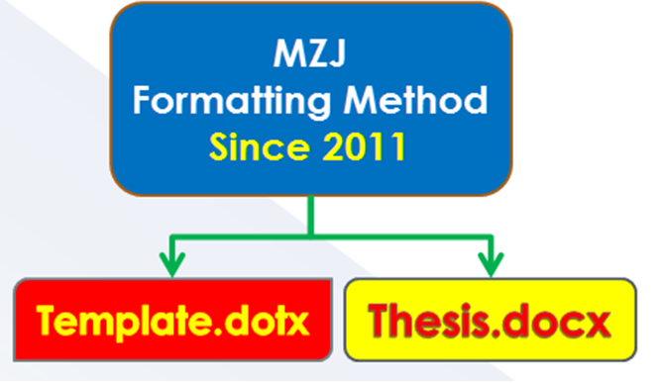
Figure 3.1 Example of Formatting Method

Chapter Summary
- Video provides a powerful way to help you prove your point.
- When you click Online Video, you can paste in the embed code for the video you want to add.
- You can also type a keyword to search online for the video that best fits your document.
- To make your document look professionally produced, Word provides header, footer, cover page, and text box designs that complement each other.
- For example, you can add a matching cover page, header, and sidebar.

PROPOSED WORK

The Big Picture
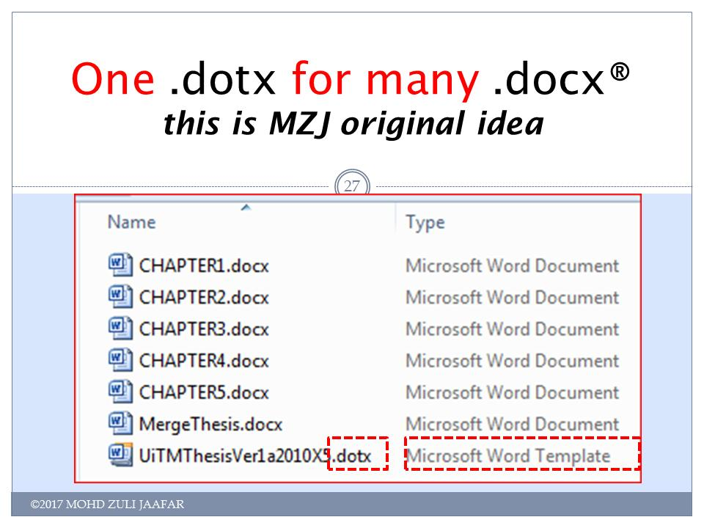
Figure 4.1 This is MZJ original idea

Analytical Proofs
- Video provides a powerful way to help you prove your point
- When you click Online Video, you can paste in the embed code for the video you want to add.
- You can also type a keyword to search online for the video that best fits your document.
- To make your document look professionally produced, Word provides header, footer, cover page, and text box designs that complement each other.
- For example, you can add a matching cover page, header, and sidebar.

Result and Discussion
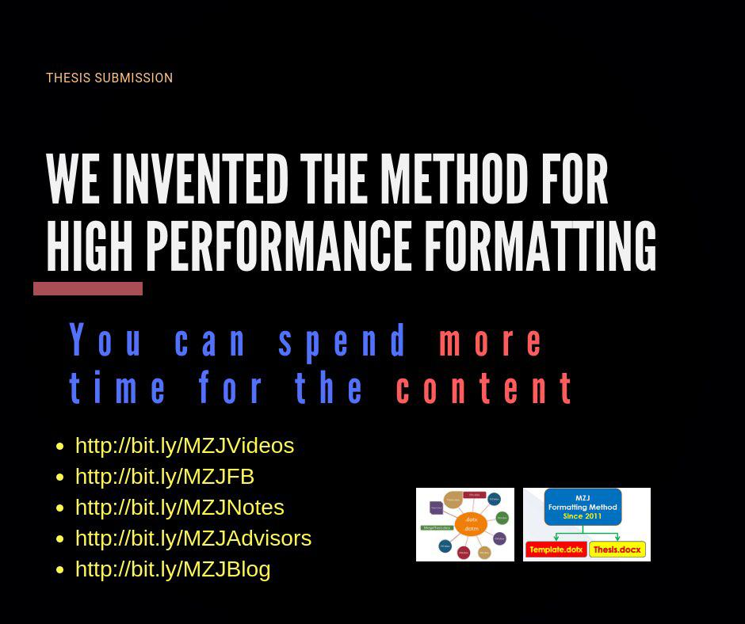
Figure 4.2 The method for hig performance formatting

Chapter Summary

Title | Title | Title | Title | Title | Title | Title
 |  |  |  | 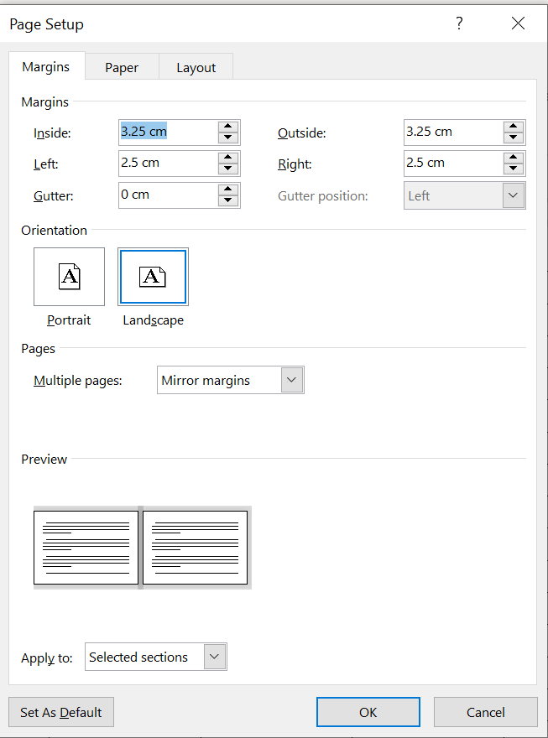

CONCLUSION AND RECOMMENDATIONS

Research Outcomes

Contributions to Knowledge

Future Works
Video provides a powerful way to help you prove your point. When you click Online Video, you can paste in the embed code for the video you want to add. You can also type a keyword to search online for the video that best fits your document.
Table 5.1 Example Repeated Header Table
Title | Title | Title | Title
Video provides a powerful way to help you prove your point. When you click Online Video, you can paste in the embed code for the video you want to add. You can also type a keyword to search online for the video that best fits your document. To make your document look professionally produced, Word provides header, footer, cover page, and text box designs that complement each other.

REFERENCES
Chen, M.-C. and Huang, S.-H. (2003) ‘Credit scoring and rejected instances reassigning through evolutionary computation techniques’, Expert Systems with Applications, 24(4), pp. 433–441.
Clerc, M. and Kennedy, J. (2002) ‘The particle swarm - explosion, stability, and convergence in a multidimensional complex space’, IEEE Transactions on Evolutionary Computation, 6(1), pp. 58–73.
Gosnell, M., Woodley, R., Hicks, J. and Cudney, E. (2014) ‘Exploring the Mahalanobis-Taguchi Approach to Extract Vehicle Prognostics and Diagnostics’, in Computational Intelligence in Vehicles and Transportation Systems (CIVTS), 2014 IEEE Symposium on, pp. 84–91.
Gupta, A. (2015) ‘Classification of Complex UCI Datasets Using Machine Learning Algorithms Using Hadoop’, International Journal of Scetific & Techology Research, 4(5), pp. 85–94.
Hu, J., Zhang, L., Liang, W. and Wang, Z. (2009) ‘Incipient mechanical fault detection based on multifractal and MTS methods’, Petroleum Science, 6(2), pp. 208–216.
Huang, C.-L., Chen, Y. H. and Wan, T.-L. J. (2012) ‘The mahalanobis taguchi system—adaptive resonance theory neural network algorithm for dynamic product designs’, Journal of Information and Optimization Sciences, 33(6), pp. 623–635.
Jain, A. K. A. K., Duin, R. P. W. and Mao, J. (2000) ‘Statistical pattern recognition: a review’, IEEE Transactions on Pattern Analysis and Machine Intelligence, 22(1), pp. 4–37.
Khalid, S., Khalil, T. and Nasreen, S. (2014) ‘A survey of feature selection and feature extraction techniques in machine learning’, 2014 Science and Information Conference, pp. 372–378.
Li, C., Yuan, J. and Qi, Z. (2015) ‘Risky group decision-making method for distribution grid planning’, International Journal of Emerging Electric Power Systems, 16(6), pp. 591–602.
Lv, Y. and Gao, J. (2011) ‘Condition prediction of chemical complex systems based on Multifractal and Mahalanobis-Taguchi system’, in ICQR2MSE 2011 - Proceedings of 2011 International Conference on Quality, Reliability, Risk, Maintenance, and Safety Engineering, pp. 536–539.
der Maaten, L. J. P., Postma, E. O., den Herik, H. J., van der Maaten, L., Postma, E. O., van den Herik, J., der Maaten, L. J. P., Postma, E. O. and den Herik, H. J. (2009) ‘Dimensionality Reduction: A Comparative Review’, Technical Report TiCC TR 2009-005, 10(January), pp. 1–41.
Motwani, R. and Raghavan, P. (1996) ‘Randomized algorithms’, ACM Computing Surveys, 28(1), pp. 33–37.
Qinbao Song, Jingjie Ni and Guangtao Wang (2013) ‘A Fast Clustering-Based Feature Subset Selection Algorithm for High-Dimensional Data’, IEEE Transactions on Knowledge and Data Engineering, 25(1), pp. 1–14.
Rao, V. M. and Singh, Y. P. (2013) ‘Decision Tree Induction for Financial Fraud Detection’, in Proceeding of the International Conference on Artificial Intelligence in Computer Science and ICT (AICS 2013), pp. 321–328.
Shi, Y. and Eberhart, R. (1998) ‘A modified particle swarm optimizer’, 1998 IEEE International Conference on Evolutionary Computation Proceedings. IEEE World Congress on Computational Intelligence (Cat. No.98TH8360), pp. 69–73.
Soylemezoglu, A., Jagannathan, S. and Saygin, C. (2011) ‘Mahalanobis-Taguchi system as a multi-sensor based decision making prognostics tool for centrifugal pump failures’, IEEE Transactions on Reliability, 60(4), pp. 864–878.
Theodoridis, S., Koutroumbas, K., Holmstrom, L. and Koistinen, P. (2009) Pattern Recognition, Wiley Interdisciplinary Reviews Computational Statistics.
Zaki, M. J., Wong, L., Berry, M. J. A., Linoff, G. S., Hegland, M., Zaki, M. J. and Wong, L. (2003) ‘Data Mining Techniques’, WSPC/Lecture Notes Series: 9in x 6in, 10(1–2), p. 545.

Appendix A Mathematical Proofs

Appendix B Psuedo Code

Appendix C Time-series Results Long Long Long Long Long Long Long Long Long Long

LIST OF PUBLICATIONS

Mary Duncan Carterand Rose Mary Magrill, “Building Library Collections" Fourth edition. (Metuchen, N. J.: Scarecrow Press, 1974), pp.61 - 66.

