Razak Faculty of Technology and Informatics
Kuala Lumpur, Malaysia
16 December 2021

TITLE OF THE PAPER

First A. Author*¹, Second B. Author2 and Third C. Author3

^{1, 2} Department, Institute, City, COUNTRY
firstauthorsname@aaaa.bbb, secondauthorsname@aaaa.bbb
³ Department, Institute, City, COUNTRY
thirdauthorsname@aaaa.bbb

ABSTRACT
The abstract should not be more than 200 words each. The abstract should not only indicate the subject and scope of the paper but also summarize the author’s conclusion. Structured abstract must be a brief, comprehensive summary of the contents of the article. It allows readers to survey the contents of an article as fast as possible. An abstract summarizes the major aspects of a paper. It should succinctly summarize the purpose of the paper, the methods used, the major results, and conclusions.
Key words: Keyword 1, Keyword 2, Keyword 3 (Minimum 3 key words and maximum 5 Key words)

INTRODUCTION
This format is used for submissions that are published in the proceeding of the ICHCKM 2021. Authors should follow the guidelines and used this exact abstract format to maintain a consistent and high-quality appearance.

Citation must follow example here (Jamal et al., 2010). According to Samsul (2011), the larger the gap the slower it become. References must be written with surname and followed by initial as the example in the references. Arrange according to its first letter in ascending order (A-Z).

Authors are requested to submit the extended abstract (maximum of 4 pages in the length) in electronic form (MS-Word) via the online submission. The incorrect format may result in your abstract being returned to you by e-mail. The scientific committee will select the contributions for conference proceeding and journal publication.

A digital version of the ICHCKM 2021 proceedings will be published in the conference website. After the conference, selected submissions will be invited to be extended into full papers for publishing in SCOPUS indexed journals or periodicals.

.

MAIN RESULTS
The extended abstract should be written in MS Word format in single-spaced in 12 point Times New Roman. Do not indent the text paragraphs. Please briefly explain the problems statements with the support from literature, the aim and scope of the study, the materials and methods, and the main findings and brief analysis of the study. Figures can be included here and referred to in the text. A table also can be inserted like the one below and referred in the text.
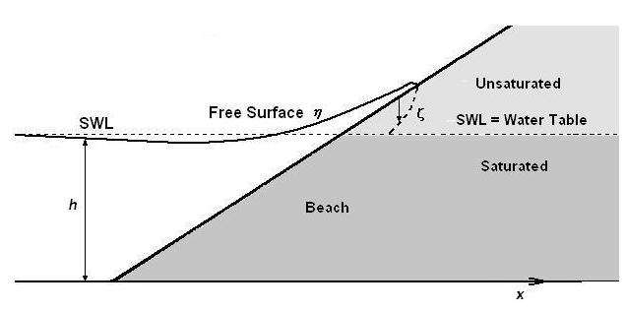
Figure 1. Example of figure for the extended abstract

Table 1. Example of table for the extended abstract
 | A = 0.56 | B = 0.69 | C = 0.75 | D = 0.100
AB₁ | 14.0640 | 18.5620 | 22.0817 | 18.90732
AC₂ | 61.6728 | 44.7844 | 44.5884 | 60.17496
AD₃ | 88.1380 | 118.1564 | 101.2240 | 120.72693
DB₄ | 199.8594 | 173.1269 | 194.4907 | 188.75258
DA₅ | 246.7889 | 255.9483 | 284.6633 | 262.24264

CONCLUSION
The conclusion is intended to help readers understand why the findings should matter to them. A conclusion is not merely a summary of the main topics covered or a re-statement of the research problem but a synthesis of key points and recommendation of new áreas or improvement for future research.

Acknowledgment: If authors wish to acknowledge funding bodies and other parties, the acknowledgments may be placed in a separate section at the end of the text, before References.

REFERENCES
Butt, T. and Russell, P. (2000). Hydrodynamics and cross-shore sediment transport in the swash-zone of natural beaches: A review. Journal of Coastal Research, 16 (2), 255-268.
Jamal, M.H., Simmonds, D.J., Magar, V. and Pan, S., (2010). Modelling infiltration on gravel beaches with an XBeach variant. Proceedings of 32nd International Conference on Coastal Engineering, No. 32(2010), Shanghai, China, paper no. 156, 1-11.
Pedrozo-Acuña, A. 2005. Concerning swash on steep beaches. PhD thesis, University of Plymouth, U.K.
Samsul, A. R. (2011). The influence of anything to anything. Coastal Engineering, 22, 29-40.

