Extended Abstract Title
Author’s name and surname ¹ and Author’s name and surname ²

1 Graduate School of Business Administration, Meiji University, 1-1 Kanda-Surugadai, Chiyoda Tokyo 101-8301, Japan
2 Razak Faculty of Technology and Informatics, Universiti Teknologi Malaysia, 54100 Kuala Lumpur, Malaysia

Abstract – Abstract should be written in 200 words and with 11 font size, Calibri (Body), italic, justified, single line spacing. Objectives, methods, and findings are summarized in this section.

Keywords: Keywords regarding the work stated in the section. Said section should contain maximum 5 words that are written with calibri (body) font, 10 font size and separated with semi-colon.
1. Introduction

Extended abstracts should be written according to underlying structure of the structured abstract and in a form that is shorter than the full text. Subtitles of the extended abstract should be composed from the sections of abstract and keywords, introduction and objective, method, findings and argument, conclusion and suggestions. Extended abstract of the full paper shall be written with Calibri (body) font, single line spacing and 12 font size.
Extended abstracts can contain figures, tables, formulations or images. Extended abstracts should be in a structure that explains the content of the declaration therefore the preparation phase of the said work. Extended abstracts should have a minimum of 2 pages and should not exceed 4 pages including the references.
Current literature regarding the work subject should be examined and the differences of the said work from the past, similar works should be presented clearly in the introduction section.

2. Materials and Methods

All materials and methods that have been used in the work must be stated clearly and subtitles should be used when necessary.

2.1 Research Site
Second degree subtitles (2.1) should be written should be left aligned and italic. The paragraph should be in right indention (as in template).

3. Results and Discussions

3.1 Subtitle
All of the tables, images and figures should be centered. Figures and images should be numbered together (Figure 1) and figure definitions should be placed under the figure or image; as for the tables, they should also be numbered (Table 1) and the table header should be placed at the top of the chart.

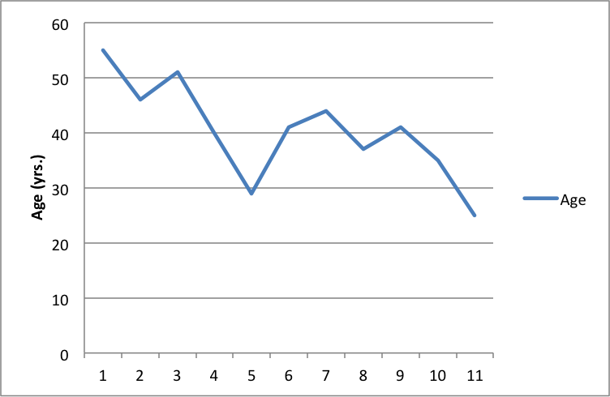
Figure 1. Age in the Writing Center

Table 1. Correlation coefficient and descriptive statistics for each variable
4. Conclusion
Please conclude your work incorporating your most important finding as well as future works (3-4 lines).

Acknowledgement
Please acknowledge your research grant, organization, scholarship (where relevant)

References

Total no. of references must not exceed 15. Resources that have been presented inside [ ] in the text with numbers should be listed according to their order in the text. References that have been presented in the references list should be prepared in a format according to the reference type shown below:

If the reference is an article;
[1] Pommiera, S., Chenub, D. and Quintardb, M. 2007. Modelling of moisture-dependent aerobic degradation of solid waste, Waste Management, 28, 7, 1188-1200.

If the reference is a book;
[2] Li, G., Hart, A. and Gregory, J. 1998. Flocculation and sedimentation, 295, Technomics Press, Lancaster PA.

If the reference is a chapter of a book;
[3] Blackburn, T. 1998. Flocculation and sedimentation in Li, G., Hart and A. Gregory, J., eds, Physical Processes, Technomics Press, 29-45, Lancaster PA.

